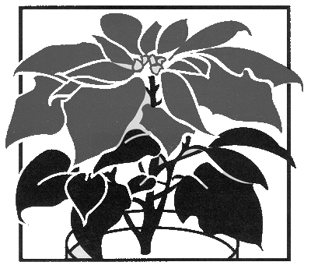
Help Us
Decorate the
Church this Season

Your donation helps us purchase poinsettias and other Christmas decor. Any funds left after decorating for Christmas will go into the Flower Fund to be used for other special events and occasions (such as funerals).

Suggested donation is $15, and the deadline is Sunday, December 16.
Complete the form below and put it and your check (or cash in a marked envelope) in the offering plate or deliver it to the church office. Checks should be made out to “St. Thomas’ Altar Guild.”

Acknowledgment of your gift will appear in the bulletins. Please print.

Given By: _____________________________________________
(as you wish to be listed in the bulletin)

Phone Number: ________________ # of dedications: ______
Check as appropriate:
______ In Memory of____________________________________

______ In Memory of____________________________________

______ In Memory of____________________________________

______ In Memory of____________________________________

______ In Honor of _____________________________________

______ In Thanksgiving for _______________________________

______ In celebration of _________________________________

For more information, contact Marcia Bracy, mbracy1976@gmail.com
Help Us
Decorate the
Church this Season

Your donation helps us purchase poinsettias and other Christmas decor. Any funds left after decorating for Christmas will go into the Flower Fund to be used for other special events and occasions (such as funerals).

Suggested donation is $15, and the deadline is Sunday, December 16.
Complete the form below and put it and your check (or cash in a marked envelope) in the offering plate or deliver it to the church office. Checks should be made out to “St. Thomas’ Altar Guild.”

Acknowledgment of your gift will appear in the bulletins. Please print.

Given By: _____________________________________________
(as you wish to be listed in the bulletin)

Phone Number: ________________ # of dedications: ______
Check as appropriate:
______ In Memory of____________________________________

______ In Memory of____________________________________

______ In Memory of____________________________________

______ In Memory of____________________________________

______ In Honor of _____________________________________

______ In Thanksgiving for _______________________________

______ In celebration of _________________________________

For more information, contact Marcia Bracy, mbracy1976@gmail.com

